Retrieving data
Table of Contents
What is this assignment about? 2
Before you start 2
Questions 2
Submitting your assignment 3

What is this assignment about?
In this assignment, you will create indexes for the football database.
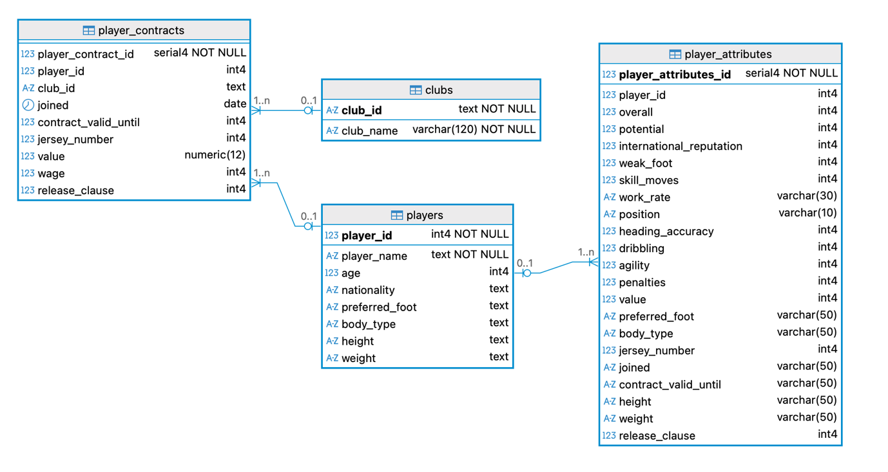

Before you start
- If you do not have access to the football database, run the file football.sql.
- Make sure you comment each query explicitly with the question number and the question you are answering.
- Show the efficiency of the index through EXPLAIN ANALYZE before and after creating the index (check classroom examples if you are unsure).

Questions
Question 1: Your manager complains that reports for specific nationalities are slow.
- Write a query to list all players from Germany. Show player_name, age and nationality. Check how long this query takes to run.
- Now, create an index on players(nationality) and re-run the query you wrote for part a.
- Write a comment on your SQL script explaining if there were any improvements after creating the index.
Question 2: The finance team frequently wants a report with the top-paid players across all clubs.
- Write a query that returns player_name, club_name, and wage. Use EXPLAIN ANALYZE to check how long that query takes to run.
- Create an index on the wage column and re-run the query you wrote for part a.
- Write a comment on your SQL script explaining if there were any improvements after creating the index.
Question 3: Your manager wants details on expensive players, with market_value above 5,000,000.
- Write a query to list all players whose market)value > 5,000,000, displaying the player_name, club_name, value and wage. Use EXPLAIN ANALYZE to check how long that query takes to run.
- Create a partial index that only stores rows with market_value above 5,000,000. Re-run the query you wrote for part a.
- Write a comment on your SQL script explaining if there were any improvements after creating the index.
Question 4: The whole team is happy with your efficient new queries, except for the people in charge of the server – they say you might be using too much space and ask for a report. Write a query that shows the space used by each index you created. Your results should be presented in a single table, with each row showing the size of each index.

Submitting your assignment
Make sure you submit your assignment by the end of the lab session and demonstrate it to your lab instructor.

